LAB 4
SUBNETTING AND SUPERNETTING USING CISCO PACKET TRACER

OBJECTIVES

To gain practical understanding of how IP networks are divided logically using Subnetting and how multiple networks can be combined through Supernetting.

To develop and apply both fixed-length and variable-length subnet mask (VLSM) schemes to create efficient network designs.

To configure and implement the designed topology in Cisco Packet Tracer, ensuring proper routing between different subnets.

To observe and analyze the packet flow across subnets via a router, verifying connectivity and network performance.

THEORY
- Subnetting
Subnetting is the practice of dividing a single physical network into two or more smaller logical sub-networks (subnets). It involves borrowing bits from the host portion of the IP address to create a subnet field.
Operation: It works by applying a subnet mask that extends the default network portion. For example, borrowing 2 bits from a Class C /24 network creates 4 subnets. The router uses the subnet mask to determine which network segment an IP address belongs to.
Application: Used to improve network performance and security by reducing the size of the broadcast domain. It ensures that traffic meant for a local subnet stays local.
- Supernetting
Supernetting, also known as Classless Inter-Domain Routing (CIDR) or route summarization, is the inverse of subnetting. It allows multiple smaller networks to be combined into a single larger network.
Operation: It involves manipulating the subnet mask to move the network boundary to the left (reducing the number of network bits). This creates a summary address that represents a block of contiguous networks.
Application: Used primarily to reduce the size of routing tables on routers, which reduces CPU and memory usage and speeds up the routing process on the Internet.

NETWORK DESIGN

Subnetting
Calculations
Network Address: 192.168.1.0/24
Required number of subnets: 4
Number of IP address per subnet: 64 (Block size)
/26 (Borrowed 2 bits: 2² = 4 subnets)
Subnet Mask: 255.255.255.192

Subnet Calculation Table
Subnet | Network ID | 1st Host | Last Host | Broadcast ID
1 | 192.168.1.0 | 192.168.1.1 | 192.168.1.62 | 192.168.1.63
2 | 192.168.1.64 | 192.168.1.65 | 192.168.1.126 | 192.168.1.127
3 | 192.168.1.128 | 192.168.1.129 | 192.168.1.190 | 192.168.1.191
4 | 192.168.1.192 | 192.168.1.193 | 192.168.1.254 | 192.168.1.255

Network Topology
Subnetting:
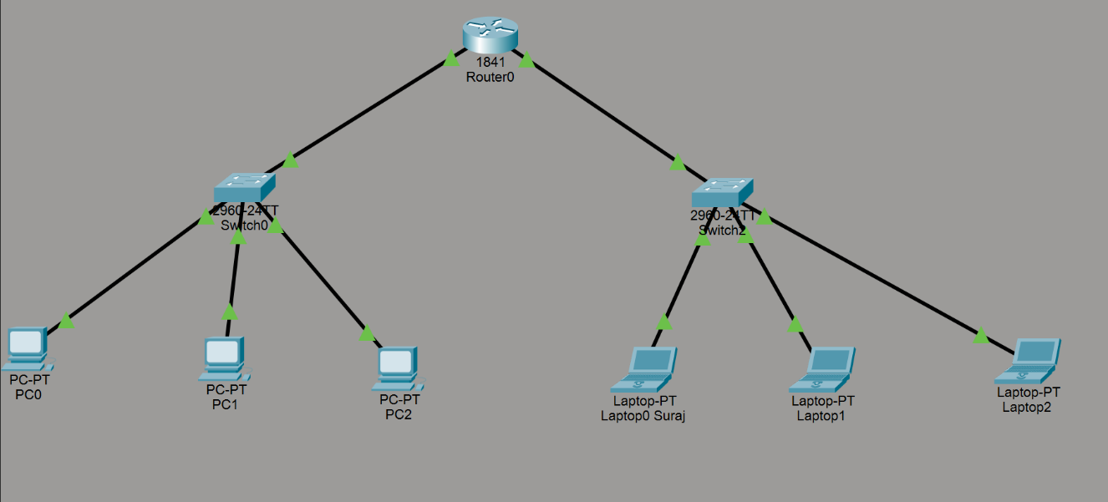
A topology was created using Router0 to connect two subnets: 192.168.1.0/26 and 192.168.1.64/26. Switch0 connects PC0, PC1, and PC2 in the first subnet, while Switch1 connects Laptop0 Suraj, Laptop1, and Laptop2 in the second subnet. Both switches are linked to separate interfaces on Router0, allowing communication between the two subnets.
Supernetting:
A topology was created using Router1 to connect a single subnet through a switch. The switch connects five PCs: PC3 Suraj, PC4, PC5, and PC6, all within the same network segment. Each device is linked using straight-through Ethernet cables, and the switch is connected to Router1 to enable external network access.
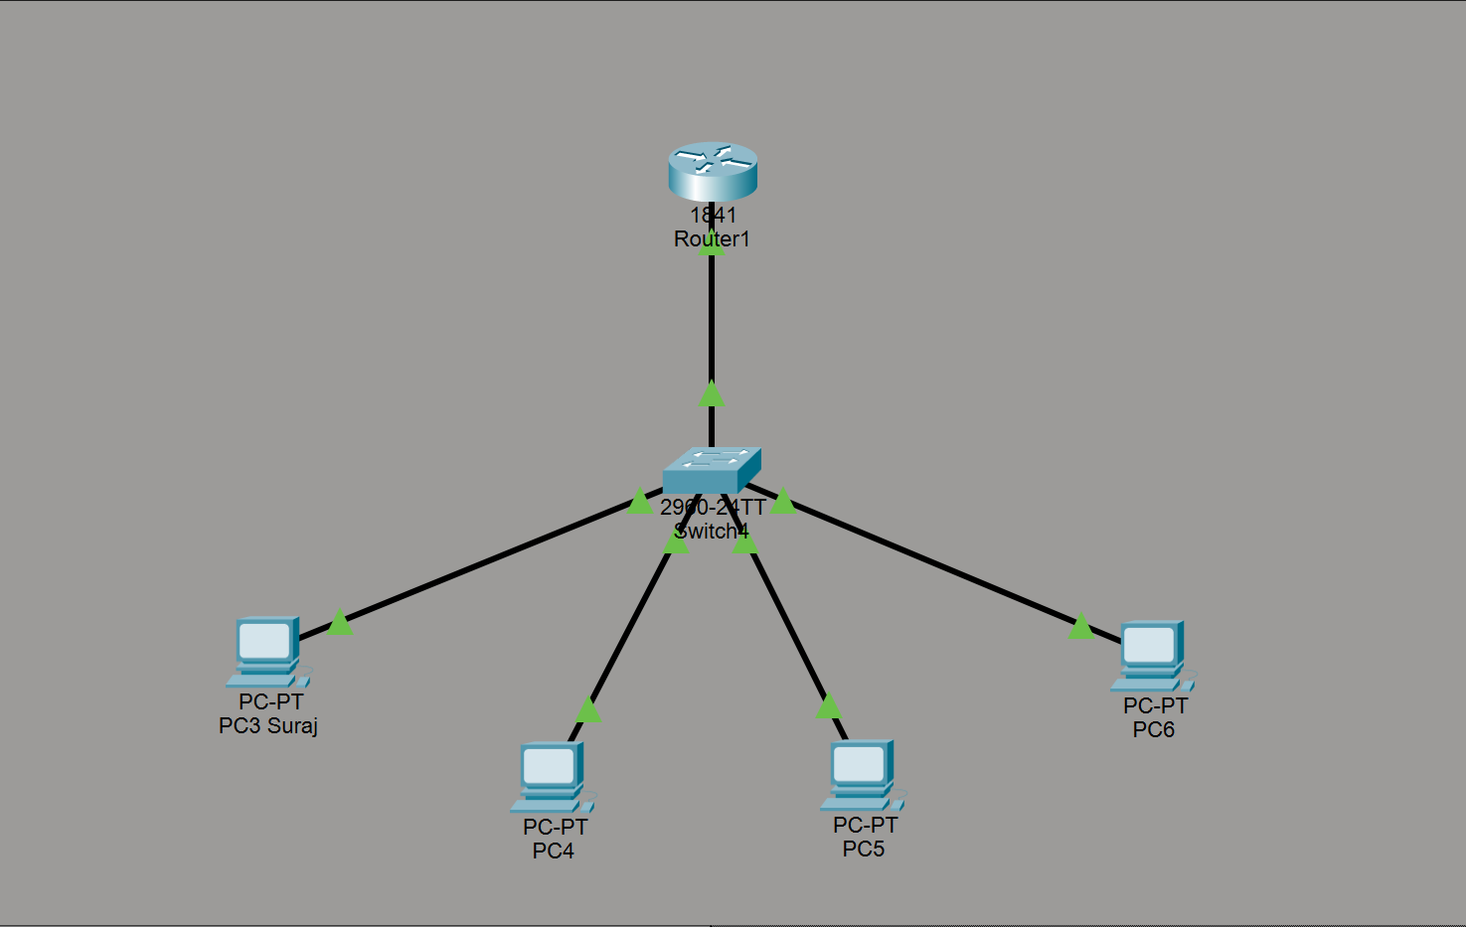
CONFIGURATION TABLE

Subnetting :

Device | IPV4 | Subnetmask | Default gateway
Router0  (FastEthernet0/0) | 192.168.1.1 | 255.255.255.192 | N/A
Router0  (FastEthernet0/1) | 192.168.1.65 | 255.255.255.192 | N/A
PC0 (Subnet 1) | 192.168.1.2 | 255.255.255.192 | 192.168.1.1
PC1 (Subnet 1) | 192.168.1.3 | 255.255.255.192 | 192.168.1.1
PC2 (Subnet 1) | 192.168.1.4 | 255.255.255.192 | 192.168.1.1
Laptop0 (Subnet 2) | 192.168.1.66 | 255.255.255.192 | 192.168.1.65
Laptop1 (Subnet 2) | 192.168.1.67 | 255.255.255.192 | 192.168.1.65
Laptop2 (Subnet 2) | 192.168.1.68 | 255.255.255.192 | 192.168.1.65
Supernetting
Device | IPV4 | Subnetmask | Default gateway
Router1  (FastEthernet0/0) | 192.168.1.1 | 255.255.252.0 | N/A
PC3 (Suraj) | 192.168.1.10 | 255.255.252.0 | 192.168.1.1
PC4 | 192.168.1.10 | 255.255.252.0 | 192.168.1.1
PC5 | 192.168.2.10 | 255.255.252.0 | 192.168.1.1
PC6 | 192.168.3.10 | 255.255.252.0 | 192.168.1.1

DISCUSSION
In this lab, we explored the concepts of subnetting and supernetting by designing and implementing IP addressing schemes using Cisco Packet Tracer. Subnetting was used to divide a larger network into smaller, manageable segments, each with its own subnet mask. This allowed us to assign IP ranges efficiently and reduce broadcast traffic. We implemented two subnets—192.168.1.0/26 and 192.168.1.64/26—connected via a router, demonstrating inter-subnet communication. Supernetting, on the other hand, was discussed as a method to aggregate multiple networks into a single routing entry, improving routing efficiency and reducing table size. The topology helped visualize how routers handle traffic between subnets and how switches manage local device communication.

CONCLUSION
The lab successfully demonstrated the practical application of subnetting and supernetting in network design. The use of Cisco Packet Tracer provided a clear visualization of packet flow and device interaction across subnets. Overall, the session enhanced our understanding of logical network segmentation and efficient routing strategies in both small and scalable network environments.

